Supervisor: Dept: ______________________ Date: ___/___/___
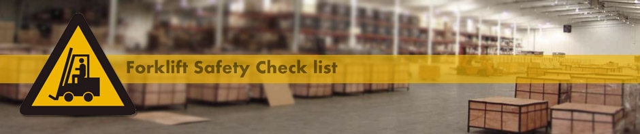

Forklifts are powerful machines that have made moving materials easier and faster. Forklifts come in various types and sizes and when operated safely, they are valuable tools. But when used by untrained operators or careless operators taking shortcuts, the results can be fatal.

According to the Bureau of Labor Statistics, almost 100 workers are killed every year and another 20,000 are seriously injured in forklift-related incident. Forklift tip-overs are the leading cause of forklift fatalities with other incidents involving crushed-by, struck-by and fall from forklifts.

DO NOT BECOME A STATISTIC! Many incidents can be prevented with proper training, awareness and consistent safe work practices. Follow these best practices to avoid forklift accidents:

- Never operate a forklift unless you are over 18 years old, trained and certified.
- Conduct pre-operation inspections daily or before each shift.
- Check the controls, brakes, horn, lights, fluids, tires, and other safety devices.
- Never drive a defective forklift!
- Always wear your seatbelt!
- Never jump out of a tipping forklift. Always stay in the operator’s cab. The cab is designed to protect you.
- Make sure the load is stable and securely placed on the forks
- Do not overload the lift!
- Keep the load as low as possible.
- Do not raise or lower the forks while the forklift is moving.
- Lift workers only in approved platforms.
- Avoid sharp turns because this moves the center of gravity and cause tip-overs.
- Always look in the direction of traffic and make sure you have a clear view of path.
- Watch for pedestrians.
- Separate pedestrian traffic from forklifts
- Always go backwards down a slope.
- Always face your load uphill.
- Do not allow passengers to “catch a ride.”
- When leaving the forklift, lower the forks and neutralize the controls, shut it off and set the brakes.

Remember, OSHA requires operators to have refresher training at least once every 3 years or when the operator has been observed driving unsafely, involved in an accident or near- miss incident or whenever workplace conditions change in a manner that could affect the safe operation of the truck.

