Supervisor: Dept: ______________________ Date: ___/___/___

When it’s time to use a Fire Extinguisher, just remember PASS!
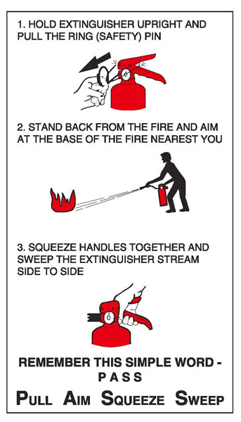
PULL
Pull the Pin

AIM
Aim the nozzle or hose at
the base of the fire from the
recommended safe distance of 6-8ft.

SQUEEZE
Squeeze the operating
lever to discharge the fire
extinguishing agent.

SWEEP
Sweep the nozzle or
hose from side to side until
the fire is out. Move forward
or around the fire area as the
fire diminishes. Watch the
area in case of re-ignition.

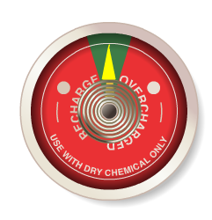

*Visually Inspect Fire extinguishers monthly. Is the pin intact? Is the gauge showing the correct pressure? Is the extinguisher visible and accessible?

* Recharge annually and maintain with local, state and national codes.

