Supervisor: Dept: ______________________ Date: ___/___/___

Personal Protective Equipment (PPE) General Requirements

As an employer, you must assess your workplace to determine if hazards are present that require the use of personal protective equipment. If such hazards are present, you must select protective equipment and require workers to use it. You must communicate the type of PPE you have selected to your workers and select PPE that fits accordingly.

Once you have selected the type of PPE your workers are required to wear, you must train them on the following:
- How to use equipment correctly, including how to properly don on and off.
- How to maintain equipment, including proper inspection and cleaning.
- Know when the equipment must be used.
- Know and understand the limitations of the equipment in protecting workers from injury.
- Choose the right equipment for the task.

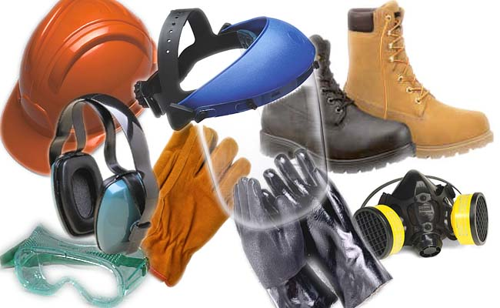
The following are areas that usually warrant the use of Personal Protective Equipment (PPE). Employers are responsible for conducting hazard assessments to identify areas where the following may apply:

Eye Protection

Workers performing tasks that may expose the eyes to hazards of flying chips, sparks, chemical splashes, dust, laser, radiation must be protected by the use of eye glasses, goggles, or face shields.

Hand Protection

Workers exposed to injury that may cut, tear, burn or expose hands to harmful substances through skin absorption or extreme temperatures must be protected through the use of gloves.

Head Protection

Workers exposed to injury from falling objects, electrical injuries or contact with fixed objects must be protected through the use of hard hats.

Foot Protection

Workers exposed to injury from the hazards of falling or rolling objects, sharp objects, electrical hazards must be protected by proper footwear.

Hearing Protection

Workers exposed to excessive noise levels should be protected through the use of ear plugs, ear muffs if noise levels reach 85dBA during an 8-hr time-weighted average (TWA).

Respiratory Protection

Workers exposed to harmful dusts, fumes, mists, gases or vapors must be protected through the use of respirators. Employers must determine if a respiratory protection program is needed and provide employees with medical evaluation and training before use.

