Supervisor: Dept: ______________________ Date: ___/___/___

Falls from portable ladders are one of the leading causes of occupational fatalities and injuries. Many accidents can be avoided with common sense and good work practices. Knowing proper set-up techniques will give the ladder maximum stability and help ensure safety.

All ladders must be inspected before each use. All defective ladders must be removed from service immediately and labeled, “Defective, do not use.” Make sure to use the right size ladder for the task and that labels are visible and legible.

Inspecting Ladders:
- Check for cracks, splits, or missing rungs.
- Check for broken, split or missing side rails.
- Check hardware for loose, corroded or weakened fasteners, including spreaders and rivets.
- Check for missing or damaged feet.
- Ensure ladder is free of oil, dirt or debris.
- Check for paint – paint hides cracks, defects and other structural damage.
- Do not leave fiberglass ladders in the sun as the sun makes them brittle.

Before Using Ladders:

- Always inspect ladders prior to use.
- Ladders must be free of slippery material on rungs, steps or feet.
- Look above for any overhead wires or obstructions.
- Use non-conductive ladders for all electrical work.
- Clear any clutter from the area around the base of the ladder.
- Block off areas around the ladder to prevent displacement.
- If working close to a corner, put a sign to warn people of work presence.
- If there’s a door nearby, lock it, block it off, or station someone to monitor nearby activity.
- Do not exceed the maximum load rating of a ladder. For example, Type IA ladders are rated for 300lbs. Do not to exceed the weight of 1 worker, equipment and tool belt.

Using Ladders:

- Position a ladder carefully to prevent slipping.
- Where slipping is likely, tie off or have someone hold the ladder in position.
- Do not use a ladder for anything other than its stated purpose.
- Do not use boxes, barrels, or other objects to raise a ladder higher.
- Do not move a ladder while on it.
- Do not place ladders in front of doors opening toward the ladder unless the door is locked or guarded.
- Do not place ladders on scaffolding.
- Use a 4:1 ration when using extension ladders- one foot way from the wall for every four feet of the ladder’s length. See figure 2 below:
- Before climbing onto a roof using an extension ladder, be sure the ladder extends 3feet beyond the roof line.
- Always maintain 3 points of contact.
- Do not carry tools or materials while climbing.
- Climb facing the ladder.

Examples of Extension ladder and Stepladder:

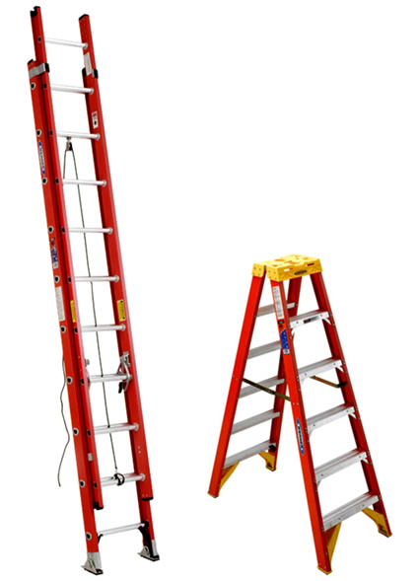
Figure 2: 4:1 Ratio for extension ladders. Touch toes to base of ladder and extend arms straight out. If fingers touch, then you have reached the correct angle

